**Worksheet**

* Use my ‘Python help sheet… .py’ or own knowledge to help you answer the questions.
* With all the questions you can answer them on the same .py file, just remember to comment (with #) the calls the functions, when you move on to the next question.
* Try make a good effort at all the data structure and algorithm questions,
  + Once you have done that, either work as a group of 3, 4 or 5 and do the group interview questions below.
  + Or learn the python libraries pygame or tkinter from the websites linked below.

**Data structures and algorithm questions**

Example questions and answers

|  |
| --- |
| Example question 1 |
| Create a function reverseStrInList, that takes in a list of strings and prints the same list but each string is reversed. |
| tests |
| reverseStrInList([‘Hello’,’World’,’How’,’Are’,’You’,’?’]) #=> ['olleH', 'dlroW', 'woH', 'erA', 'uoY', '?']  reverseStrInList([‘going’,’to’,’town’,’now’]) #=> ['gniog', 'ot', 'nwot', 'won'] |

#=> is a comment to show what it should output

|  |
| --- |
| Example question 2 |
| Create a function selection, that takes in a dictionary, and if the value is over 30, append the key to a list and print it. |
| tests |
| selectionDict({'Alex':10, 'Ben':27, 'Chris':41, 'Don':39}) #=> ['Chris', 'Don']  selectionDict({'apple':20, 'banana':4, 'cherry':36} #=> ['cherry'] |

.py file for those two questions

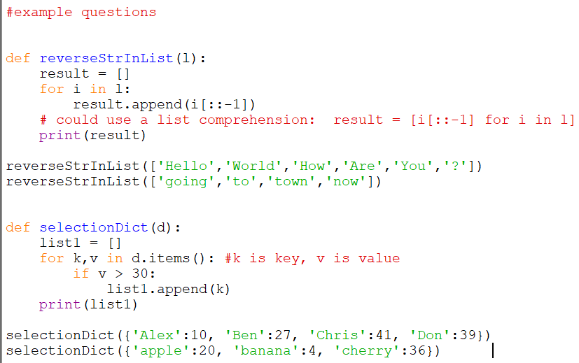

**Easy questions**

|  |
| --- |
| Question 1 |
| Create a function duplicates, that takes in a list of strings and return the duplicate characters in another list. |
| tests |
| duplicates(['b', 'y', 'i', 'i', 'a', 'y']) #=> ['i', 'y']  duplicates(['4', '4', '5', 'j', '5', 'j']) #=> ['4', '5', 'j'] |

|  |
| --- |
| Question 2 |
| Create a function strReverse, that takes in a string and prints it reversed. |
| tests |
| strReverse('hello world') #=> 'dlrow olleh'  strReverse('racecar') #=> 'racecar'  strReverse('email') #=> 'liame' |

|  |
| --- |
| Question 3 |
| Create a function passwordCheck, that takes in a string and prints ‘True’ if has at least 8 characters, 1 capital letter, 1 lowercase letter, one symbol in symbols list, and 1 number.  symbols = ['!','£', '$', '%', '&', '*', '? ', '#']. If not print ‘False’ and what condition caused that. |
| tests |
| passwordCheck('Password1! ')  passwordCheck('password') |

|  |
| --- |
| Question 4 |
| Create a function endCheck, that takes in a string and prints ‘True’ if it has the endings that’s in the ending list.  endings = ['ed', 'ing', 'ion', 'ly', 'ies'] |
| tests |
| endCheck('jumping') #=> True  endCheck('joly') #=> True  endCheck('faught') #=> False |

|  |
| --- |
| Question 5 |
| print the first, last,4th index and even index elements of the colours list.  colours = ['red', 'black', 'orange', 'yellow', 'blue', 'cyan', 'green', 'purple'] |
| code |
| colours = ['red', 'black', 'orange', 'yellow', 'blue', 'cyan', 'green', 'purple']  #your code for first index of list #=> 'red'  #your code for last index of list #=> 'purple'  #your code for 4th index of list #=> 'blue'  #your code for even index elements of list #=> ['red', 'orange', 'blue', 'green'] |

**Medium questions**

|  |
| --- |
| Question 1 |
| Create a function xify, which takes in a string and prints a placeholder string. The placeholder should have one ‘X’ for each character of string. |
| tests |
| xify('theString123') #=> 'XXXXXXXXXXXX'  xify('134897') #=> 'XXXXXX'  xify('i') #=> 'X' |

|  |
| --- |
| Question 2 |
| Create a function palindrome, that takes in a string and prints it ‘True’ if it’s a palindrome, and ‘False’ if its not. A palindrome is a word or phrase that reads the same backwards as forwards. |
| tests |
| palindrome('racecar') #=> True  palindrome('maddam') #=> True  palindrome('laptop') #=> False |

|  |
| --- |
| Question 3 |
| Create a function letterdict, that takes in a string and prints a dictionary of all the letter as keys, and the values of the number of occurrences. |
| tests |
| letterdict('bamboozle') #=> {'b':2, 'a':1, 'm':1, 'o':2, 'z':1, 'l':1, 'e':1}  letterdict('microsoftoffice') #=> {'m':1, 'i':2, 'c':2, 'r':1, 'o':3, 'f':3, 't':1, 'e':1} |

|  |
| --- |
| Question 4 |
| Create a function shift, where you are given a string and a number, n, and shift elements in a string to the right by n amount. |
| tests |
| shift('shiftingby3',3) #=> ftingby3shi  shift('abcdefgh',5) #=> fghabcde |

|  |
| --- |
| Question 5 |
| Create a function passwordgen, when called it generates a string which has a random length between 8 to 15, and contains 1 letter, 1 number, 1 symbol from the symbols list.  symbols = ['! ', '£', '$', '%', '&', '*', '? ', '#'] |
| test |
| passwordgen() |

**Hard questions**

|  |
| --- |
| Question1 |
| Scenario: You are creating an RPG game where if the player does a certain activity, it gains experience. By reach a certain amount of experience, which is different for each level, you level up. The levels go from 1 to 9.  You are currently creating a login feature to load the users past lvls and experience from your game.  Levels as an array:  Lvls = [1,2,3,4,5,6,7,8,9]  The experience cap after player levels up as an array:  Xpcap = [10,20,40,100,200,500,1000,2500,5000]  e.g. Lvl:1 xp:0/10 has 0 total experience.  Lvl:2 xp:0/20 has 10 total experience.  Lvl:3 xp:0/40 has 10+20 =30 total experience.  Lvl:3 xp:17/40 has 10+20 +17 =47 total experience  Write a function playerLevel, that takes in the total experience of a player, and print their level and current experience to reach its level cap as a string (format of string shown in the tests below). |
| tests |
| playerLevel(60) #=> lvl:3 xp:30/40  playerLevel(282) #=> lvl:5 xp:112/200  playerLevel(1250) #=> lvl:7 xp:380/1000  playerLevel(2222) #=> lvl:8 xp:352/2500 |

|  |
| --- |
| Question 2 |
| Create a function panel, where you are given 3 numbers and you have to create panel of numbers (as a string type). The first number determines the rows, the second number determines the column, and the third number is what number is outputted. |
| tests |
| panel(2,3,1)  #should output 111  111    panel(4,3,5)  #should output 555  555  555  555 |

If you want to practice more questions like this visit the websites leetcode and hackerrank.

**Group interview question**

Work as a group of 3, 4 or 5 and time yourselves 20 minutes (or until this session is over)

Question

Everyone in earth will die, apart from 5 candidates and you have to choose from the list: a male accountant and his wife, a doctor, a phycologist, an NBA basketball player, the current UK Prime Minister, a person who knows how to wield a katana (sword), a female singer, a priest, and a Olympic swimmer.

Remember: strategise the best way to assess each candidate, be inclusive and respectful for group members opinions, keep a track of the time, help push the discussion forward conversion forward when necessary.

**Learning**

Create a game using the pygame library

With the help of these resources:

<https://www.techwithtim.net/tutorials/game-development-with-python/pygame-tutorial/>

<https://pythonprogramming.net/pygame-python-3-part-1-intro/>

<https://www.pygame.org/wiki/tutorials>

or

Create an application using the tkinter library

<https://realpython.com/python-gui-tkinter/>